**General steps**

1. Click the "Read File" button to read a special format json file.
2. Enter the translated text in the "Target" text box.
3. Select a span (which is bold and underlined) in the "Source" text box using the mouse, then click the "Add Source Entity" button.

* Note: The selected span must contain consecutive words. Words are obtained by splitting the sentence by spaces. Punctuation marks that follow a word (if there is no space between them) are also considered part of a word.

1. Select the corresponding span in the "Target" text box using the mouse, then click the "Add Target Entity" button.
2. For each span in the "Source" text box, repeat steps 4 and 5.
3. Click the "Save && Next" button to save this annotation and start annotating the next data.

**Interface Overview**

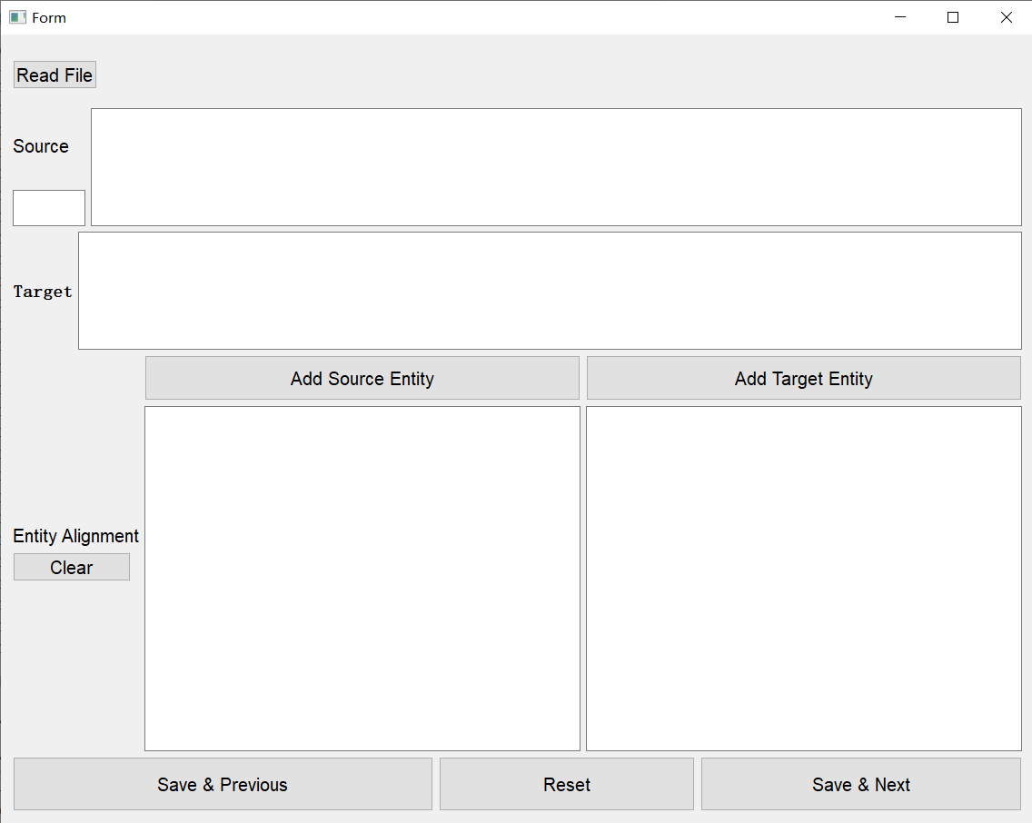

* The "Read File" button is used to read the input file. Annotations will be saved in the "output" folder. The output file is named "input-file-name_output.csv". Note that if the "output" folder already exists corresponding output file， it will automatically load it so that you can continue annotating where you left off last time.
* The "Source" text box is used to display Source text. It's not editable. You need to focus on bold and underlined spans (which are named as entities) because you need to establish a one-to-one relationship between these spans and the corresponding translated spans.
* The "Target" text box is used to edit the translated text.
* The "Add Source Entity" button and the "Add Target Entity" button are used to build a one-to-one relationships between spans. Note that you must first select the text in the corresponding text box and then click the button. The selected text and corresponding span indexes will be displayed in the "Entity Alignment" text box below.

The span indexes are counted in words, starting from 0, and does not include the right boundary of the interval.

* The "Clear" button is used to clear those one-to-one relationship between span. This is useful when you have misannotated spans but want to retain the translated text.
* The "Reset" button is used to clear both the translated text and "Entity Alignment".
* If you want to modify the previous annotation data, you can click the "Save && Previous" button.